**SQL QUERIES LAB1**

**1. Write a query to find the email addresses of employees with MANAGER_ID=101 and DEPARTMENT_ID=50 from the Employees table.**

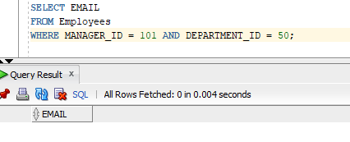

**2. Write a SQL statement to display all the information from the Departments table where the department name is ‘Finance/Sales/SA_RE’.**

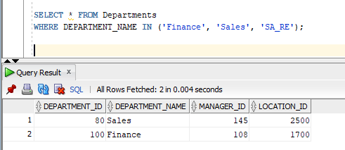

**3.Write a SQL query to find those employees whose salaries are less than 10,000 from the Employees table.**

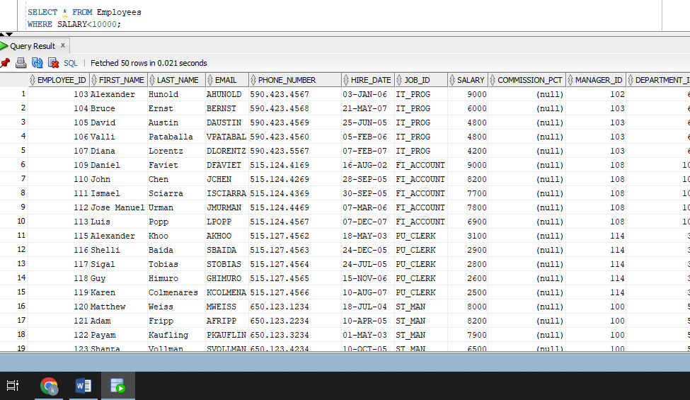

**4. Write a SQL query to find the jobs whose maximum salary is less than or equal to 20,000 from the Jobs table.**

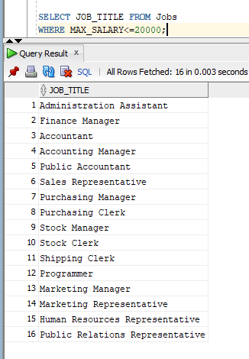

**5. Write a SQL query to find the details of employees whose last name is ‘Jones’. Return employee ID, employee first name, employee last name, and employee department ID.**

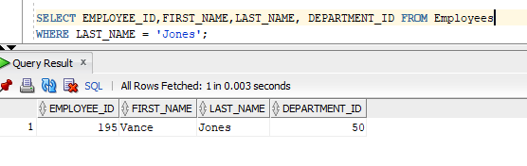

**QUERIES:**

**SELECT EMAIL**

**FROM Employees**

**WHERE MANAGER_ID = 101 AND DEPARTMENT_ID = 50;**

**SELECT * FROM Departments**

**WHERE DEPARTMENT_NAME IN ('Finance', 'Sales', 'SA_RE');**

**SELECT * FROM Employees**

**WHERE SALARY<10000;**

**SELECT JOB_TITLE FROM Jobs**

**WHERE MAX_SALARY<=20000;**

**SELECT EMPLOYEE_ID,FIRST_NAME,LAST_NAME, DEPARTMENT_ID FROM Employees**

**WHERE LAST_NAME = 'Jones';**